11430495
Indian household CCTV expenditure by class and rural/urban divide
In this blog I will be answering the question, ‘How is household CCTV expenditure impacted by class and the rural/urban divide in India?’. I will be analysing 2016 Indian household expenditure survey data. My chosen variables for this analysis are MPCE (mean per capita expenditure), CCTV sales and rurality. I chose these variables as previous literature has shown large wealth disparities between rural and urban demographics in India (Anand 2023). However, 12% of the world population resides in the Indian rural market and a greater understanding of this segment is needed for businesses to effectively tap into it (Parida and Sahney 2017). Furthermore, CCTV expenditure by rurality can provide insight into how differing demographics prioritise safety and security, demonstrating how spending behaviour is influenced by geography. I will begin this blog with a presentation of two statistical graphs followed by a short discussion of the findings and limitations of the research.

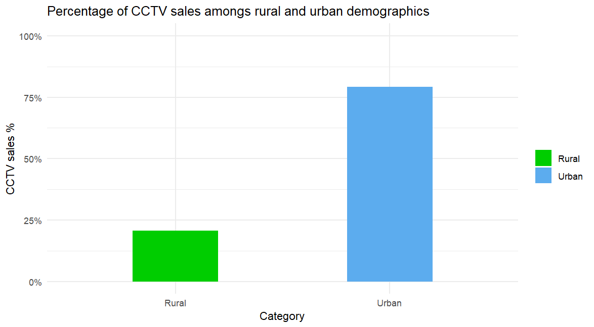
Figure 1
National sample survey office (2016)
Figure 1 presents CCTV expenditure among rural and urban demographics. Urban households make up 80% of all CCTV expenditure whereas rural households only make up 20% of the market share.
One clear reason for this disparity as identified by Anand et al (2023) is that buildings make up a much greater proportion of urban demographics assets at over 44.8% in 2012 compared to 21% in rural demographics. This would mean that rural demographics have less need for expenditure on security systems as compared to urban demographics.
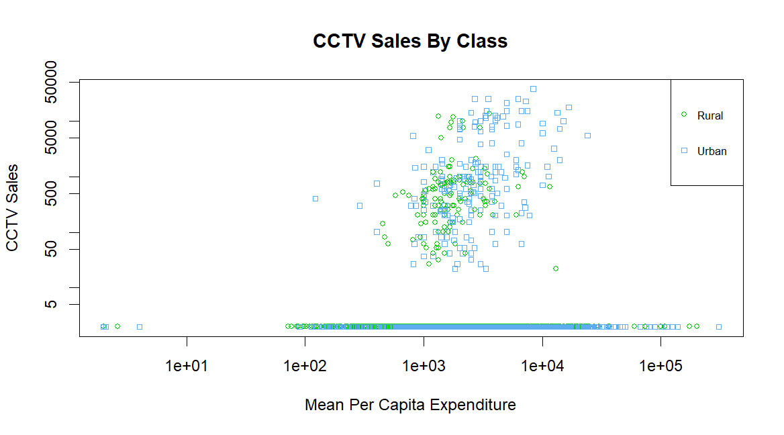
Figure 2
National sample survey office (2016)
Figure 2 shows the levels of CCTV expenditure against mean per capita expenditure whilst accounting for rural and urban demographics. MPCE is used to account for class as higher levels of spending indicate higher levels of wealth. Many of the plots fell on 0 expenditure so the plot had to be placed onto a logarithmic scale. This means the values on the axes increase exponentially to the power of 10, allowing extreme values to be represented.
This graph shows there is an observable positive correlation between higher mean per capita expenditure, CCTV expenditure and urban demographics. Research from Anand (2023) supports this, showing that even rural households with high levels of expenditure pale in comparison to the wealthiest of urban households.
However, there are limitations to the research that I have conducted. One limitation is that the data is approaching 10 years in age and may no longer be relevant to market analysts as India is rapidly developing. Furthermore, the limited scale of my analysis fails to capture other socioeconomic factors impacting CCTV expenditure such as variations in crime rates. Future research may want to cover specific states and regions within India while also accounting for these external factors.
Despite these limitations, this analysis has shown that wealthy urban households dominate the market for CCTV and security products in India due to large wealth disparities. If businesses wish to tap into the rural security market, more up to date and localised research is required.
Bibliography
- Anand, I., Thampi, A., Vakulabharanam, V. (2023). ‘Wealth inequality: the Indian case’, Canadian Journal of Development Studies, DOI: 10.1080/02255189.2023.2212898
- National Sample Survey Office, MOSPI, Government of India, (2016). ‘Household expenditure on Services and Durable goods’. Available at: India - Household expenditure on Services and Durable goods - JULY 2014 - JUNE 2015, 72 round
- Parida, R. R., Sahney, S., (2017). ‘Exploration of Indian rural markets and marketing’, Asia Pacific Journal of Marketing and Logistics, 30 (2), pp. 297-308. DOI 10.1108/APJML-12-2016-0241

